NOTIFICATION OF A FUTURE ACT UNDER DIVISION 3 OF PART 2, NATIVE TITLE ACT 1993

“OPPORTUNITY TO COMMENT – 28 DAYS”

THIS NOTICE RELATES TO THE PROPOSAL TO (CONSTRUCT A PUBLIC WORK) WHICH IS A VALID FUTURE ACT UNDER SECTION 24JA OF THE NATIVE TITLE ACT 1993.

GIVEN TO: Chairperson
Gunaikurnai Land and Waters Aboriginal Corporation
27 Scriveners Road
Kalimna West Victoria 3909
Department of Energy, Environment and Climate Action

GIVEN BY:

DATE OF ISSUE: 1 September 2026 OUR REFERENCE: Marathon Road helipad site

THE PROPOSED FUTURE ACT

CONSTRUCTION OF REMOTE WATER HELIDIP POINT – MARATHON ROAD HELIPAD SITE

The Department proposes to install several permanent remote water (helidip) points to provide helicopters with faster access to water during bushfires to support aerial firefighting across the Gippsland Region. This site was chosen due to it’s key geographical location to reduce turnaround times for first attack bushfire suppression given the long distances from reliable water sources for helicopter access. This will in turn assist in protecting communities, water supplies and environmental values.

The remote water point will consist of installing two water storage tanks (10m diameter/tank), pipes connecting the tanks and an open top helidip tank (6m diameter) and expanding the existing vegetation clearance around the helipad to accommodate safe approach and departure flight paths for the helicopters.

This location is predominantly utilising an existing helipad site and the surrounding forest was burnt in the 2006/07 bushfires. The proposed footprint of the site as shown in attached site plan will be cleared of trees and shrubs to provide clear approach and departure flight paths for helicopters when operating from the site. The footprint will be treated for clear and present danger trees and for ease of future maintenance to keep the flight paths clear.

The proposed timing of the construction of the remote water point is March – May 2027.

Plans showing the details and location of the proposal is attached.

THE FUTURE ACT IS VALID

The proposed activity is a valid future act pursuant to Section 24 JA of the Native Title Act 1993.

Subdivision J of the Native Title Act 1993 (NTA) allows for acts to be carried out on reserves provided that the act is in good faith with the purpose of the reservation. Where the act involves the construction of a public work, (which extinguishes native title rights and interests), it is necessary that formal procedural notice be given to any registered claimant and to any registered Representative Body.

In this case the proposed works are to be carried out over land that was validly reserved prior to 23/12/96. The future act is in accordance with the purpose of the reservation (Forest Reserve).

The proposed works are considered “a structure that is a fixture” which constitutes the establishment of public works under Part 15, Division 4, Section 253 of the Native Title Act 1993.

The extinguishment principle applies over the footprint of the works, where other acts have not yet extinguished Native Title rights and interests.

DESCRIPTION OF THE LAND OR WATERS AFFECTED:

Crown allotment 1, Parish of Toolome, Municipality of WELLINGTON (SPI:1\PP3618).

This allotment is Crown land dedicated as Reserved Forest in 1958 under the provisions of Section 42 of the Forests Act 1958.

Located on the Marathon Road on the existing helipad site.

Site Co-ordinates: 37.56286⁰ S, 147.02777⁰ E

Attached:
Cadastral plan
Aerial Photo with site Layout
Locality plan
Tank details

INVITATION TO COMMENT

The State is extending an invitation to comment on the proposed future act described above.
Comments can be forwarded to:

Stephen Poon
Traralgon Regional Office
Level 3. 8-12 Seymour Street
Traralgon, Victoria, 3844

Telephone: 0408 556283
Facsimile: 5172 2100
e-mail: stephen.poon@deeca.vic.gov.au


All comments received within 28 days of the date of this notice will be considered.

DISCLAIMER

This notification is given to you under the provisions of Division 3 of Part 2 of the Native Title Act 1993. By giving such notice, the State makes no admission or acknowledgment of any kind for the purposes of any pending or future application for a determination of native title, whether made under the Native Title Act or at common law, for the land or waters in respect of which this notice is given.


Stephen Poon
Project Manager – Remote Water, Gippsland,
Department of Energy, Environment and Climate Action

Date of Notice: 1 September 2026

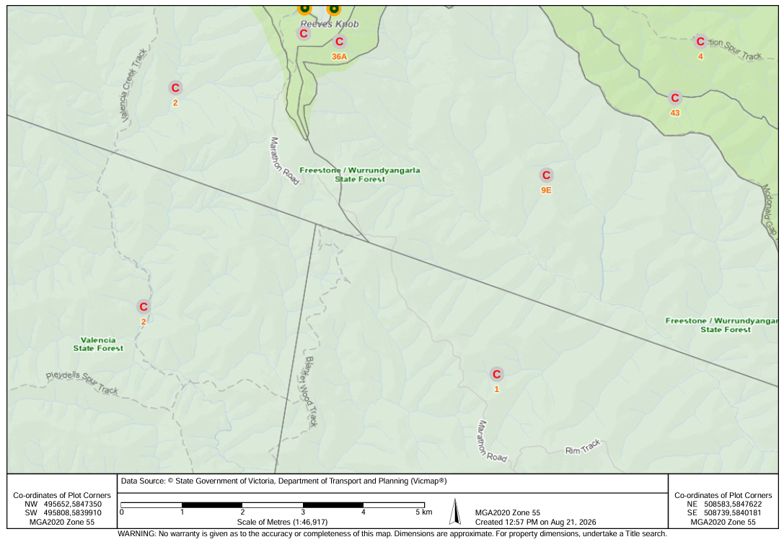
Location of Remote Water Point

Site Cadastral Plan

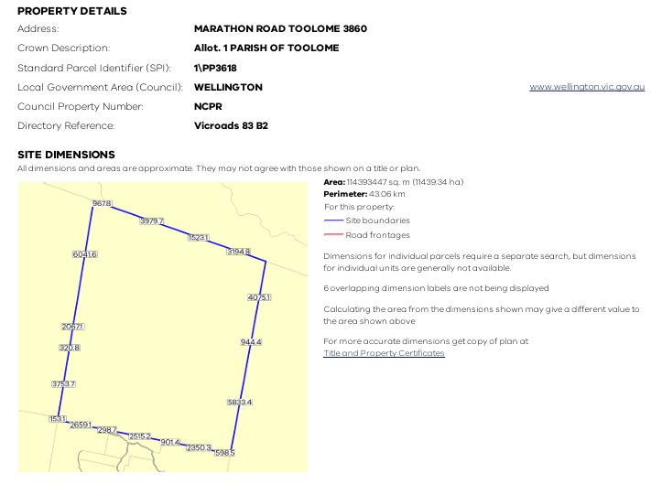
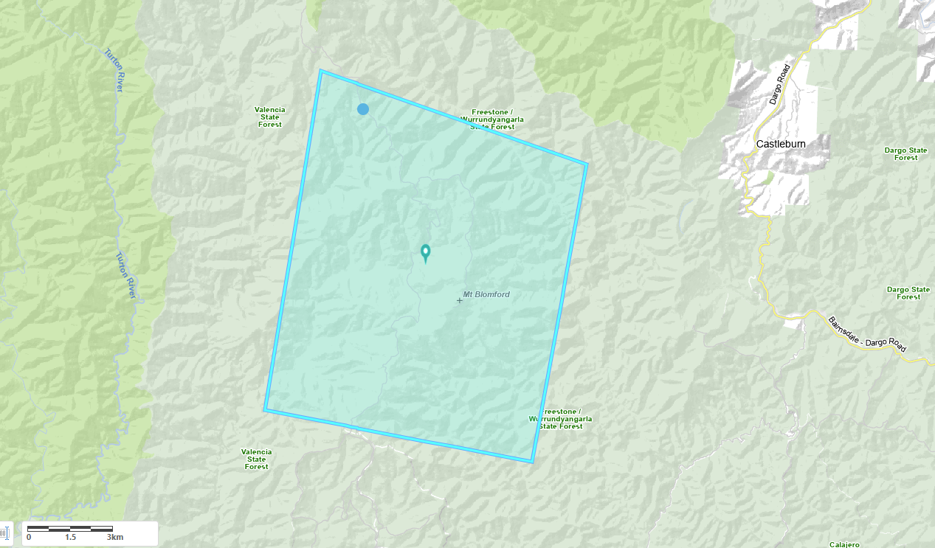

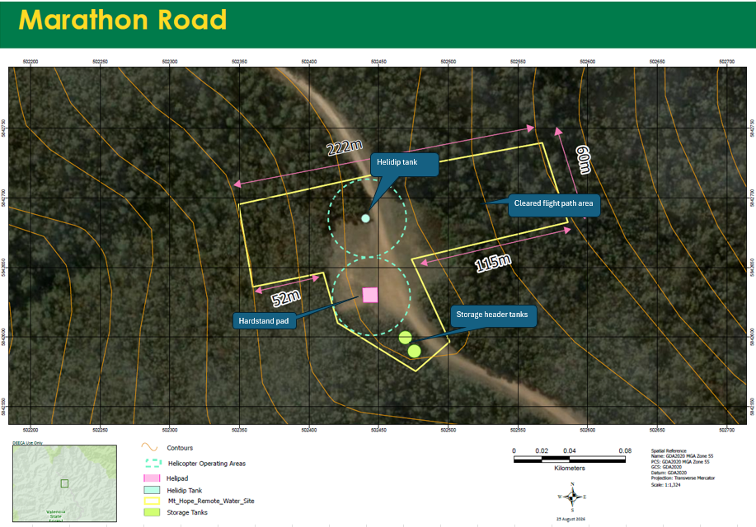

Site Layout Plan

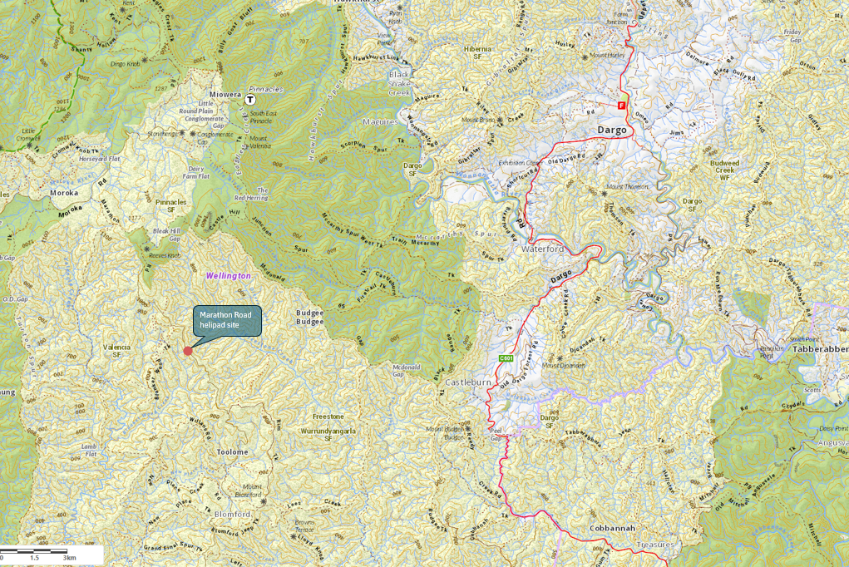

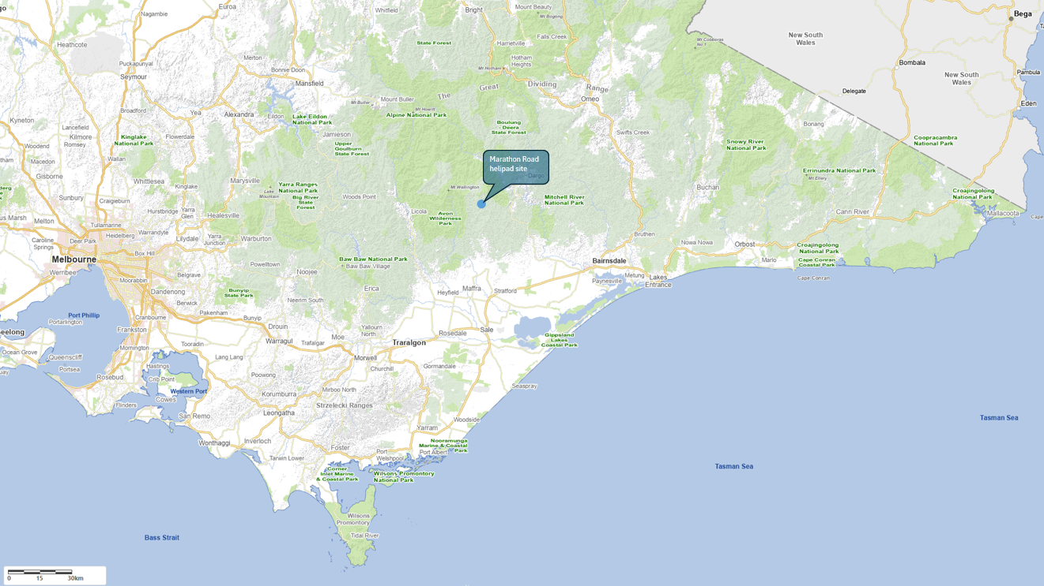

Locality Plan
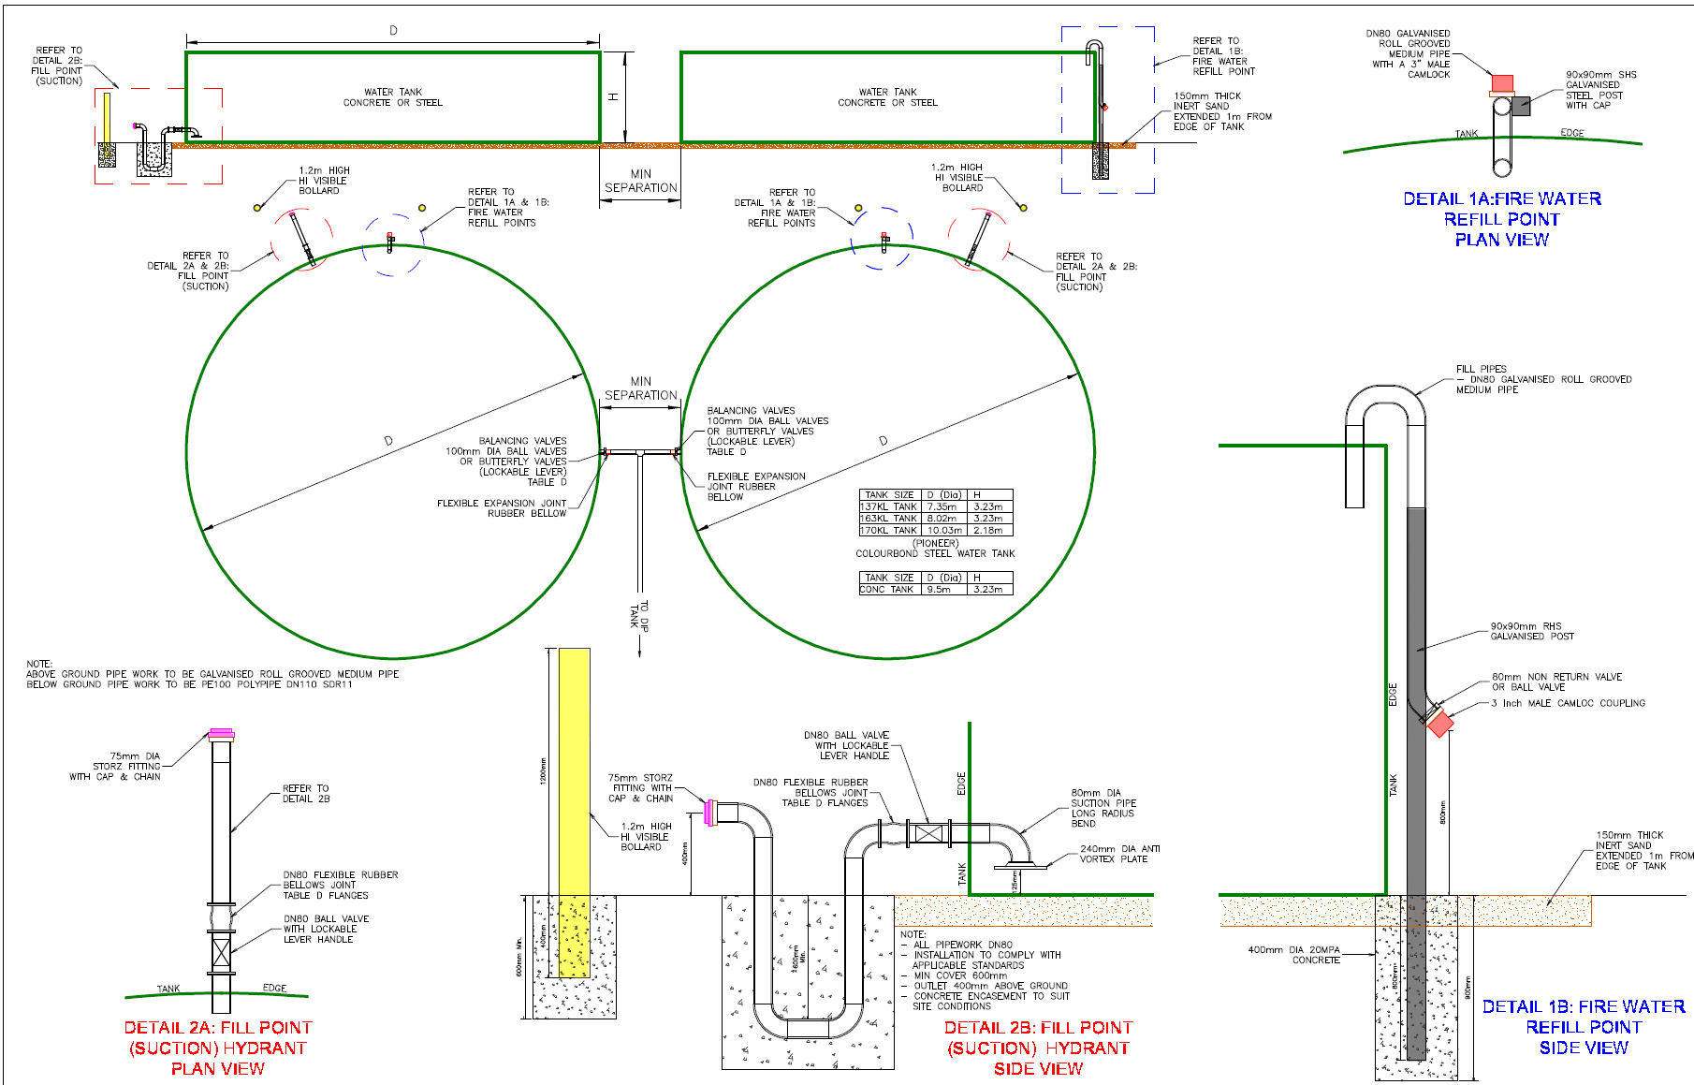

Details of Proposed Storage Tanks

